1. **Enumerate at least 3 relevant features of the game that can be used to construct the heuristic evaluation function for the game.**
2. The number of mills formed both by the player and the opponent (5 points each)
3. The number of “almost mills” (two pieces in mill position) prepared both by the player and the opponent (3 points each).
4. The number of total pieces in the board both belonging to the player and the opponent (1 point each).

The logic behind the decision of using these features is that a mill is very valuable due to them being immune to enemy attacks if there are still other pieces in the field not belonging to a mill; a mill can frequently also be “reused” for attacks by moving one of the pieces that forms it back and forth. Those pieces that are “almost mill” are also valuable because they are 1 piece away from forming a mill and taking one of the opponent’s pieces off the game. The total number of pieces is a very intuitive feature because one of the ways of reaching the end of the game is by leaving one player with only two pieces.

1. **Write a formula for your evaluation function**

The evaluation function for this heuristic takes the form:

With specific weights defined as follows:

Where:

* *f1* is the number of mills that the player has.
* *f2* is the number of mills that the opponent has.
* *f3* is the number of “almost mills” that the player has.
* *f4* is the number of “almost mills” that the opponent has.
* *f5* is the number of total pieces the player has remaining in the field.
* *f6* is the number of total pieces the opponent has remaining in the field.

1. **Evaluate the following boards using your evaluation function. Show the evaluation of each feature.**

**Board 1 Board 2**

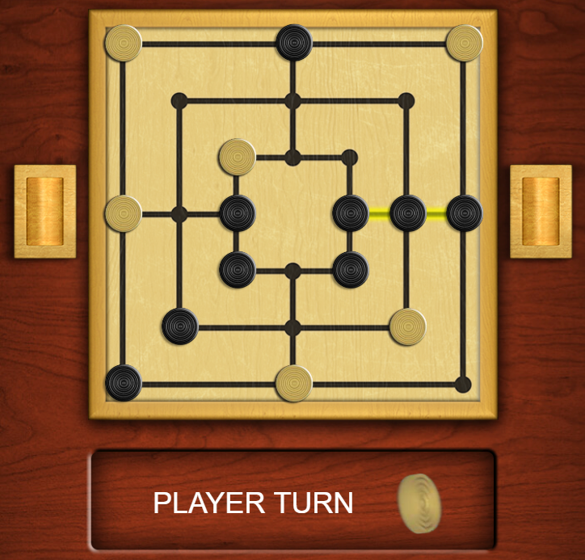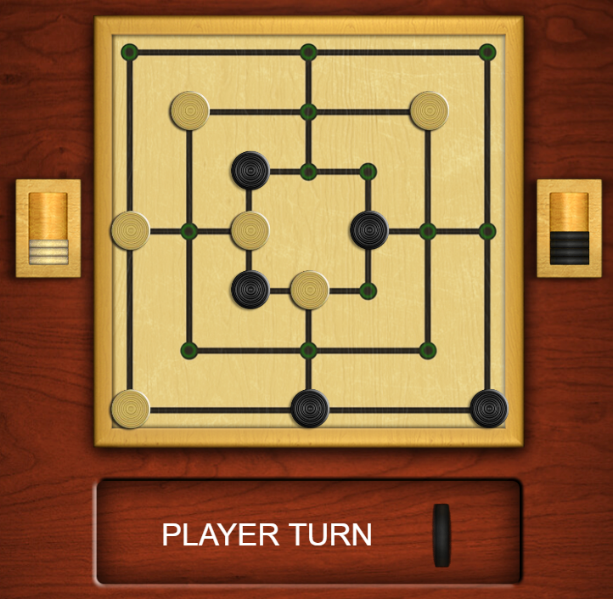

**Board 3**

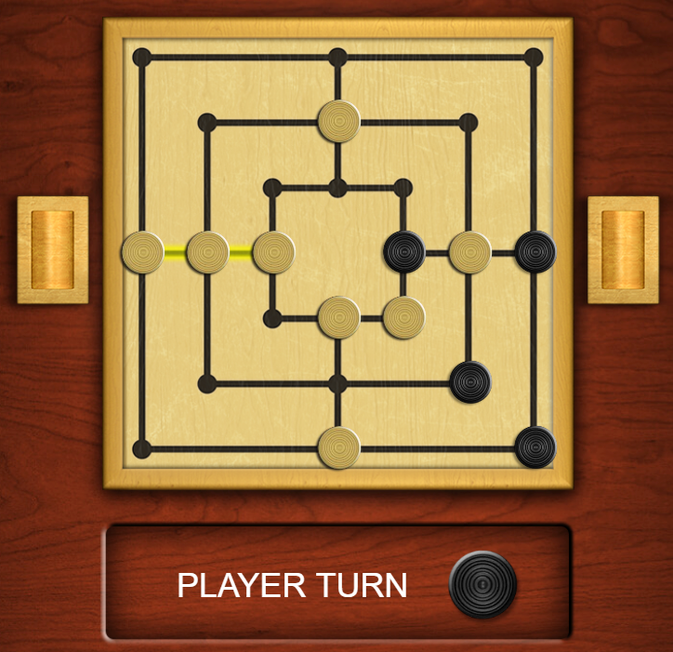

Board 1:

Board 2:

Board 3: